Software Requirement Specification Document
For

MEDICAL MANAGEMENT SYSTEM

- Introduction
  - Purpose

Table of Contents

Page Numbers

  - Intended Customers/Users
  - Product Scope
  - Outline of the document
- Overall Description
  - Product Perspective
  - Product Functions
  - User Classes
  - Design and Implementation Constraints
- Diagrams
  - UML Diagrams
  - ER Diagrams
  - DFD Diagrams
  - Assumptions and Dependencies
- External Interface Requirements/Screenshots
  - User Interfaces
  - Hardware Interfaces
  - Software Interfaces
  - Communication Interfaces
- Other Non-Functional Requirements
  - Performance Requirements
  - Safety Requirements
  - Security Requirements
  - Software Quality Attributes
  - Business Policies/Rules (if any)
- Testing
  - Block-Box Testing
  - White-Box Testing
- Conclusion
- References
- Acknowledgements

INTRODUCTION

The Medical Management System is designed to manage health operations efficiently and accurately by introducing security in place of the traditional manual record-keeping. Problems associatedwithlargeamountsofpaperwork,dataredundancy,delaysinaccess,andahighrisk of human error are very common in healthcare institutions. The proposed system shall provide a centralized platform for managing all records of patients, appointments, and their respective medical information.
This system allows ease of management in day-to-day activities of medicine, maintains
confidentiality in patient-related data, and has easy accessibility for the medical history of a
patient to an authorized user. Therefore, the Medical Management System will provide better coordinationamongalltheprofessionalswithinthisfieldandraisethequalityofpatientservice both in hospitals and clinics by automating major activities and thereby supporting role-based
access.

PURPOSE

Theproposedaimoftheprojectisthedesignofamedicalmanagementsystemthatwouldbe more efficient and easier to use and would provide digital copies of medical histories, appointments,andmedicalrecords.Theproposedsystemwouldminimizepaperworkanderrors inthehandlingofmedicalrecordsandalsoprovideamorepreciseandmoreefficientmethodof medical records management.

INTENDED CUSTOMERS/USER

TheMedicalManagementSystemcontainsseveraluserclasseswithdistinctresponsibilities. The responsibilities of Physicians include viewing and editing patient medical records, viewing medical histories, and prescribing treatments. The responsibilities ofNurses include viewing patient records for assisting recording and updating patient treatments and vital signs. The
responsibilitiesofFrontdeskstaffandreceptionistsincludepatientregistration,appointments, and patient basic records management. The responsibilities of medical administrators include supervising system operations, user management, report generation, and security of patient records. Other users including authorized medical staff access patient records depending on their respective user profiles and privileges.

PRODUCTSCOPE

TheMedicalManagementSystemdealswiththemanagementofpatientregistration, appointment scheduling, and recording medical information. In this manner, it digitizes
healthcareinformationandreducespaperdocumentstoaminimum,minimizinghumanerrorin record-keeping and facilitating the secure storage, retrieval, and updating of patient records.
Accordingly,role-basedaccessallowsforsensitiveinformationtobeaccessedonlybythe authorizeduser,bringingincreasedefficiencyandaccuracywithintheoperationforbetter healthcare services at hospitals and clinics.

OUTLINE OFTHE DOCUMENT
The Medical Management System is described in detail in the Software Requirement Specification (SRS) document below.An overview of the system, the rationale behind its development, the target audience, the goal of the SRS document, and the software's scope are providedintheintroductionorchapter1ofthedocument.Theoverallsystemcontext,functional requirements, user classification, system designs, and the plan for the test process are covered in other chapters of the SRS document. The document is organized according to a standard SRS format.

OVERALLDESCRIPTION
The Medical Management System, refers to the computer-based solution that can automatemedicalmanagementfunctionsperformedatahealthfacilitysuchashospitalsand medical clinics. The medical management system is a replacement for the manual or paper-
basedsystemthathasbeenusedinthemanagementofhealthfacilities.Thecomputer-based solution increases access to patient information, thereby coordinating medical functions
performed in the hospital or medical facility.

The system has the ability to handle different roles of users in the system, which may be
doctors,nursepractitioners,frontofficestaff,andmedicaladministrators,eachhavingunique log-inaccesslevels.Thesystemhasmechanismsthatguaranteesecurityandconfidentialityin the storage and access of sensitive patient/medical information. The Medical Management
Systembelievesinminimizingpaperwork,curtailinghumanerrors,andoptimizingtheprocess in any healthcare organization to enable effective decision-making.

PRODUCTPERSPECTIVE

AcentralizeddigitalsolutionismadecalledtheMedicalManagementSystem(MMS)to take the place of conventional manual healthcare management procedures in order to make things easier to operate. Current systems are largely dependent on workflows which are not
joint properly and paper-based records, which causes a lot of delays, errors, difficult to deal withandmakesthingsproblematic.Patientrecords,appointments,medicalhistories,billing, and resource management are all integrated into a single platform by the proposed software
whichistitledasMedicalManagementSystem.Itmakescoordinationbetweenvariousmedical departments within the sector easier and gives authorized medical personnel access to patient data and the information.

PRODUCTFUNCTION
The Medical Management System is designed to function in accordance with certain fundamentalfunctionsthatsimplifyandmanagetheprocessofoperationsinthehealthcarefield, besides ensuring that the security and reliability of the data are in place.
    - Patient Registration &Appointments
Italsosupportstheregistrationprocessofpatients,optimalmanagementofrecords,aswellas appointment scheduling, with the aim of simplifying healthcare activities.

    - Medical Records & Prescription Management
Itprovidesthefacilitytomanagethemedicalhistory,prescriptions,andotherassociatedmedical data, which can be done in an organized and simplified way.
    - Authentication &Security
Thesystemoffersuserauthenticationsecurityforsafeguardingsensitivemedicalinformation,so that only authorized users are able to access it.
    - Reporting and Data Retrieval
The system is capable of generating reports as well as retrieving data.This will help
administrators and healthcare professionals when it comes to analysis as well as monitoring.

USER CLASSESAND CHARACTERISTICS
The Medical Management System will serve a restricted number of precisely identified usercommunities.Thiswillservetoensureatargeted,secure,anduser-friendlysystem.Theuser communities will possess particular duties based upon their role in the medical setting.
    - Doctors
The doctors are the main clinical users and consequently need complete access to the patient’s medical details. They read and update the patient’s medical files, analyse the patient’s medical history,prescribemedicationstothepatient,andfollowuponthepatient’scontinuingtreatment.
Thedoctorsarenormallyconversantwiththeclinicalsystemandthusneedperfectandfast access to the patient’s details.

    - Nurses

Theroleofnursesinvolvesassistingdoctorsinattendingtopatientsbygainingaccesstopatients that have been assigned.They work with the system as they provide care to patients and need an efficient system for accessing patients.

    - Front desk employees and receptionists.

Thistypeofuserisresponsibleforpatientregistrationandscheduling,aswellasbasicrecording. They also possess fewer technical duties and therefore demand an easier-to-use interface so that they can execute their administrative tasks while not accessing critical healthcare information.

    - MedicalAdministrators

Themedicaladministratorsmanagetheentireprocessoffunctioninginthissystem.Themedical administrators are responsible for user management, system parameters, security policies, reporting, and data integrity. The medical administrators should have full access to the system and should have strong control functionality. ·Authorized Medical Staff Other healthcare
professionalsareincludedinthiscategory.Theyaregivenaccessusingtherolesthathavebeen assigned to them. They use the system for the tasks that are only related to their jobs.

DESIGNANDIMPLEMENTATIONCONSTRAINTS
AnydesignandimplementationoftheMedicalManagementSystemhavetobedeveloped undercertaindesignandimplementationconstraints,whichhavetobeconsideredforsecurity and performance feasibility.

- Constraints for Security and Privacy
The system has to be designed based on the set of healthcare data security and privacy regulations.ItneedsRole-BasedAccessControltolimitvariouslevelsofaccessandprotect sensitive patient information.
- Constraints of performance
Thesystemshouldhandlelargepatientdatavolumeswithoutperformancedegradationtohandle operation in hospitals and clinics smoothly.
- Network and infrastructure constraints
Accesstoandupdatingofdatarequiresreliablenetworkavailability,especiallyinthose environments dependent on centralized or cloud-based data storage.
- Resource and Development Constraints
Thedevelopmentanddeploymentofthesystemarerestrictedbytheavailableprojecttimeline, budget, and resource availability.

OVERALLDESCRIPTION
The Medical Management System and its interactions with different types of users, includingallpatient,LabTechnician,doctors,andadministratorsaredepictedbythediagram.In order to do the tasks like patient registration, appointment scheduling, medical record management, and report generation, it demonstrates role-based access through login system. To increase accessibility and coordination and the people, the system centralizes data of all the patients. It guarantees the privacy and security of all the medical data. Overall, the diagram
emphasizesincreasedefficiencyinhealthcaremanagementi.e.medicalmanagement,decreased paperwork, and automation of hospital operations.

UMLDIAGRAM

TheinteractionbetweentheMedicalManagementSystemandtheusersofthesoftware,suchas doctor, patient, lab technician, and the admins, and it is depicted by the UMLUse Case Diagram. It

is used to demonstrates how each user gains access to the software using permissions based on the roles and secure the authentication process. One of the important features of this system includes patient record management, appointment scheduling, treatment updates, billing, and report generation are explained in the given below use case diagram. It emphasis strongly on system security of all the documents, it also centralizes the data handling, and medical information confidentiality.Ingeneral,thediagramshowshowhospitaloperationsareautomatedbythesystem to increase productivity anddecision-making.

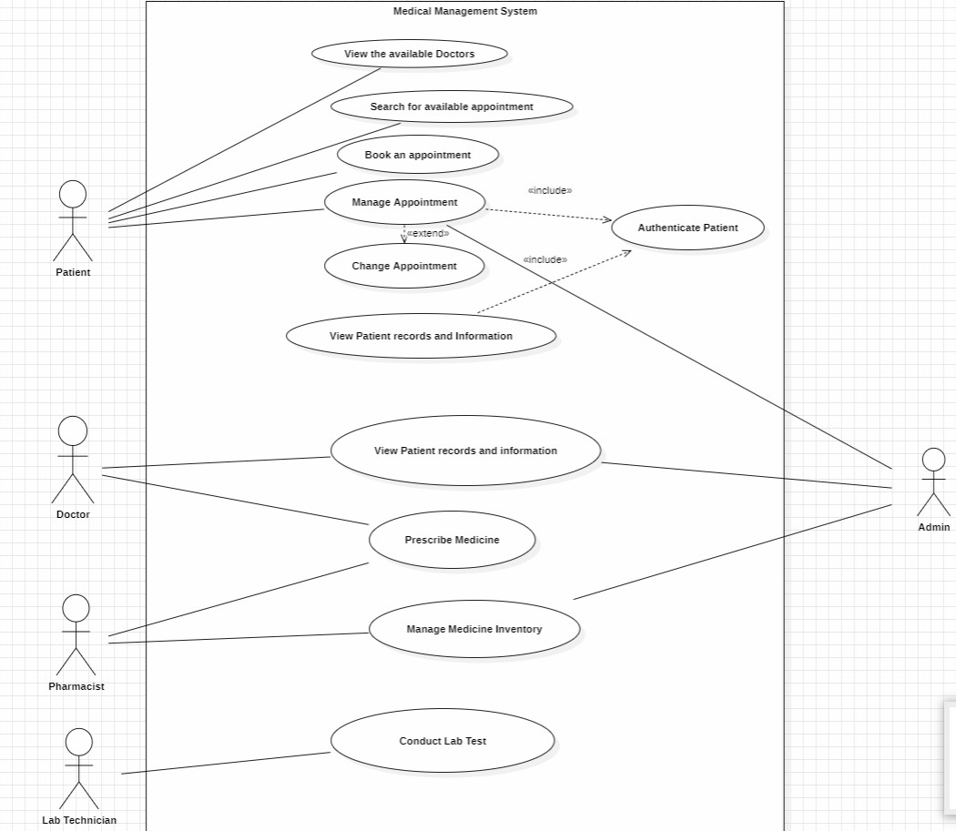

CLASS DIAGRAM

TheMedicalManagementSystemhasaUMLClassDiagramthatshowswhatthesystemlooks like when it is not doing anything.This diagram has lots of classes. It shows how these classes are connected to each other in the Medical Management System. The classes, in the Medical

Management System are really important because they help us understand how the Medical ManagementSystemworks.TheUseristheclass.ThisUserclassisusedasabasebyclasseslike Patient, Doctor,Admin, Pharmacist and LabTechnician. The Patient class and the Doctor class and theAdmin class and the Pharmacist class and the LabTechnician class all inherit, from the User class.People who are patients can make an appointment.Then change it if they need to.The doctors are the ones who handle the appointments. They are also the ones who generate the
prescriptions for the patients.Medical records store diagnosis, treatment, and test results of
patients.Pharmacists are in charge of managing the medicines. They make sure everything is okaywiththemedicines.Labtechniciansdotestsinthelab.Theyalsomakereports,aboutwhat they find out from these tests. The lab technicians and the pharmacists do work with the
medicinesandthelabtests.Thediagramclearlyrepresentshowusers,appointments,medical records, medicines, and lab tests are interconnected.

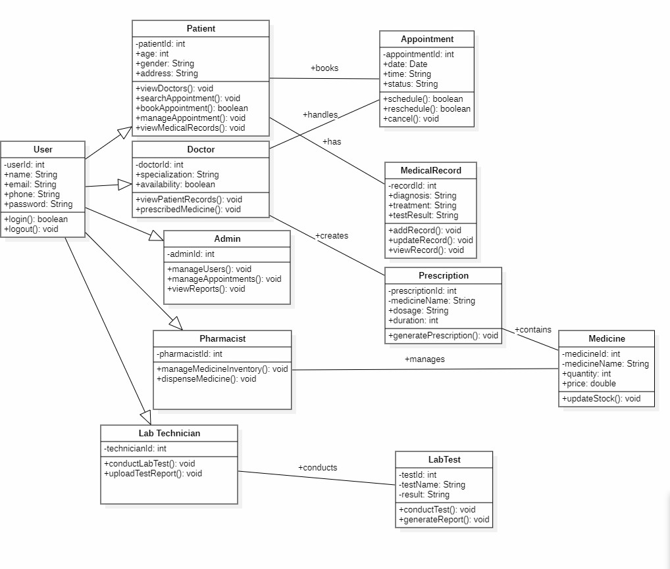
  - DFD
- The Level 0 Data Flow Diagram (DFD) for the Medical Management System represents the overallinteractionbetweenthecentralsystemanditsexternalentities.TheMedicalManagement System acts as the main process that manages patient information, appointments, medical records, and system access. The Front Desk Staff sends patient registration details, appointment schedules, and requests to the system. Physicians interact with the system by providing medical

history,recordedits,andprescriptions,whilealsoaccessingpatientrecords.Nursesreceivecare instructions from the system and update it with patient vital signs and treatment information.
Patientssubmitregistrationinformationandappointmentrequestsandreceiveconfirmationsand summaries.Authorized Medical Staff send access requests and receive filtered patient records based on permissions. The MedicalAdministrator manages user access policies and receives systemreportsandusagelogs.Overall,thesystemensuresefficientdataflow,secureaccess,and proper coordination among all users in the healthcare environment.

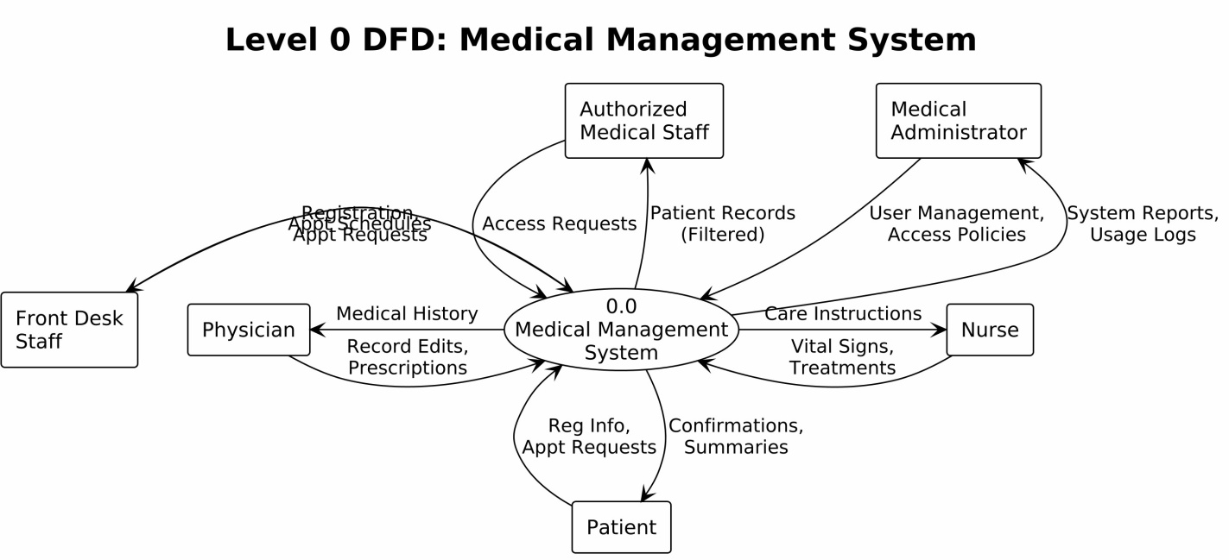
- Testing
- TESTING
Black Box Testing:
Without even understanding the code internally or the structure, black box testing verify the functionality of the software. It determine if the system operates correctly, the tester merely supplies inputs and confirms the outputs.
White Box Testing:
White box testing looks at the program's internal logic, structure, and code. Knowing the source code, the tester examines the program's loops, conditions, and paths.
  - White box testing
White Box Testing is a testing technique where the tester has complete knowledge of the internal code and logic of the program. In the given program, different paths and conditions inside the calculate_bill function are tested, such as invalid input, normal case, senior citizen discount, insurance coverage, and emergency surcharge. Each test case checks whether the internal logic and calculations of the code work correctly, ensuring that all conditions and execution paths are properly verified.
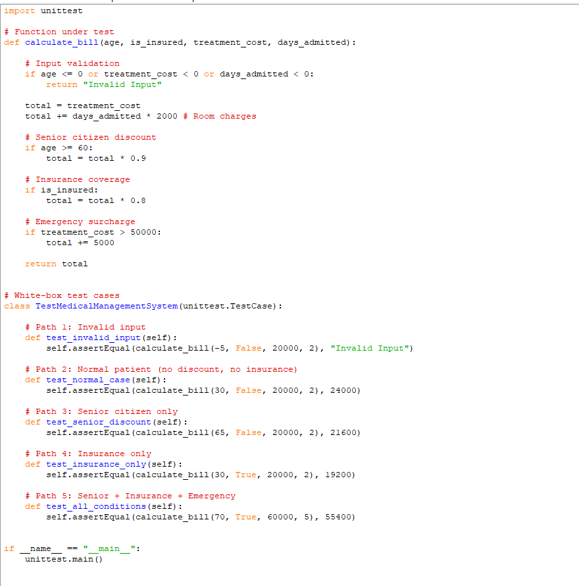
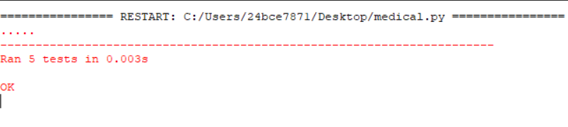

FLOW DIAGRAM NOTATION
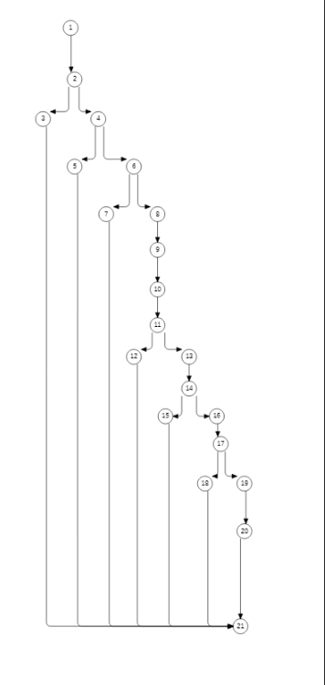

CYCLOMATIC COMPLEXITY
The Cyclomatic Complexity of the calculate_bill module is calculated using the formula:
V(G) = Number of Decision Nodes + 1
Decision nodes identified in the flow graph:
age ≤ 0
treatment_cost< 0
days_admitted< 0
age ≥ 60
is_insured
Total Decision Nodes = 5
Therefore,
Cyclomatic Complexity
V(G) = 5 + 1 = 6
INDEPENDENT PROGRAM PATH
Following the notation style in your reference, here are the independent paths for the calculate_bill code. Since there are 4 decision points, the complexity requires multiple paths to ensure full coverage:
Path 1: Invalid Input (First Decision True)
1, 2, 3
Scenario: Negative age or cost.
Path 2: Normal Patient (All Decisions False)
1, 2, 4, 5, 7, 9, 11
Scenario: Under 60, no insurance, low cost.
Path 3: Senior Citizen Only
1, 2, 4, 5, 6, 7, 9, 11
Scenario: Age 65, no insurance, low cost.
Path 4: Insurance Only
1, 2, 4, 5, 7, 8, 9, 11
Scenario: Under 60, has insurance, low cost.
Path 5: Senior + Insurance + Emergency (All Decisions True)
1, 2, 4, 5, 6, 7, 8, 9, 10, 11
Scenario: Age 70, insured, cost > 50,000.

  - BLACK BOX TESTING
Functional Requirements (Module: calculate_bill)
Input Validation:
If age ≤ 0, treatment_cost< 0, or days_admitted< 0, the system returns "Invalid Input".
Base Bill Calculation:
Total Bill = treatment_cost + (days_admitted × 2000).
Senior Citizen Discount:
If age ≥ 60, apply a 10% discount on the total bill.
Insurance Discount:
If is_insured = True, apply a 20% discount on the total bill.
Emergency Surcharge:
If treatment_cost> 50000, add a ₹5000 surcharge to the final bill.
Equivalence Partitioning
Equivalence Partitioning is a black-box testing technique where the input domain is divided into equivalence classes. Each class represents a group of inputs that are expected to produce similar behavior. Instead of testing every possible input, one representative value from each class is selected to reduce the total number of test cases while still covering all input conditions.
Equivalence Classes for calculate_bill Module
Class ID | Input Range |  |  | Type
EC1 | age ≤ 0 |  |  | Invalid
EC2 | 1 – 59 |  |  | Valid
EC3 | age ≥ 60 |  |  | Valid (Senior Citizen Discount)
Treatment Cost  Class ID | Input Range |  |  | Type
EC4 | treatment_cost< 0 |  |  | Invalid
EC5 | 0 – 50000 |  |  | Valid
EC6 | treatment_cost> 50000 |  |  | Valid (Emergency Surcharge)
Days Admitted
EC7 | days_admitted< 0 |  |  | Invalid

EC8 days_admitted< 0 Valid
BOUNDARY VALUE ANALYSIS
- Age Boundaries (Threshold: 60)
The code applies a senior citizen discount if age >= 60. We test the exact boundary, just below, and just above it.
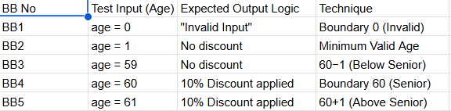
- TREATMENT COST (Threshold: 50,000)
The code adds an emergency surcharge of 5,000 if treatment_cost> 50000.
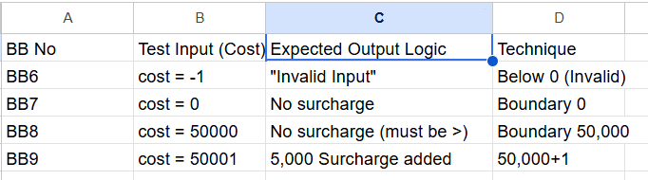
- Days Admitted Boundaries (Threshold: 0)
The code calculates room charges as days_admitted * 2000 but validates that it cannot be less than 0.
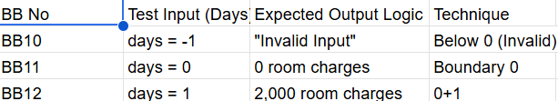

EXECUTION OF TEST CASES

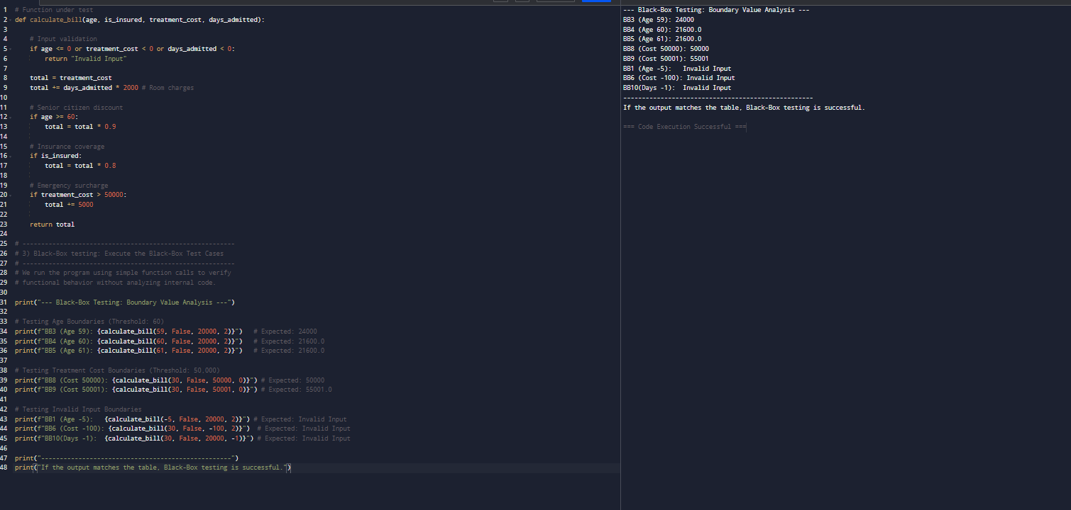

Metrics for Analysis Model
Based on your project requirements, the analysis model focuses on system functionality and size. The primary metric used here is Function-Based Metrics (Function Points), which measures the functionality delivered to the healthcare staff and patients.

Calculation of Unadjusted Function Point (UFP)

We identify the Information Domain Values from your project's functional components (Registration, Appointments, Medical Records) and apply the standard weighting factors.

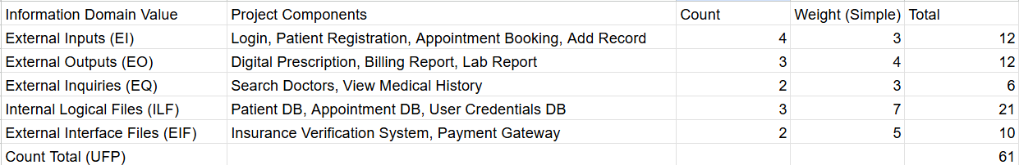

Calculation of CFA Value

The Complexity Adjustment Factor (CAF) is calculated using 14 system characteristics.

Sum of Factors ($∑$ F_i): For a medical system where security and online data entryare essential,
we assume an average rating of 3 (Average) for all 14 factors.
$∑$ F_i = 14 x 3 = 42
Formula: CAF = 0.65 + (0.01 x$∑$F_i)
Calculation: CAF = 0.65 + (0.01 x 42) = 1.07

Calculation of Function Point (FP)

The final FP indicates the functional size of your Medical Management System after adjusting for its complexity.

Formula:
FP = UFP x CAF
Calculation:
FP = 61 x 1.07
Total FP = 65.27

DESIGN ARCHITECTURE

- DEPLOYMENT DIAGRAM
The deployment diagram for the Medical Management System illustrates how everything is physically connected in real life. Imagine medical professionals, nurses, administrators, and receptionists turning on their laptops or PCs, either on the hospital's internal network or using the internet to log in from home. All of these devices communicate with a central Application Server that houses the main software. It takes care of all the important tasks, including registering new patients, scheduling appointments, retrieving medical records, and verifying logins.
The app server then communicates with a specialized database server, which maintains strict security for patient information, medical histories, schedules, and login credentials. Everyone involved can operate smoothly and safely because the entire setup keeps data in one safe location.
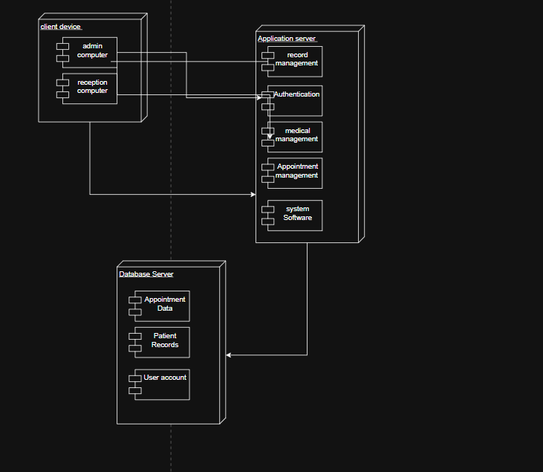

- COMPONENT LEVEL DIAGRAM
The Component Diagram of the Medical Management System shows the main parts of the software and how they interact. Users such as doctors, nurses, receptionists, and administrators access the system through the User Interface. The Authentication component verifies user login and ensures secure access. The Patient and Appointment Management component handles patient registration and scheduling. The Medical Records and Prescription component manages patient medical history and prescriptions. All system components store and retrieve data from the central database, which keeps patient records and system information securely
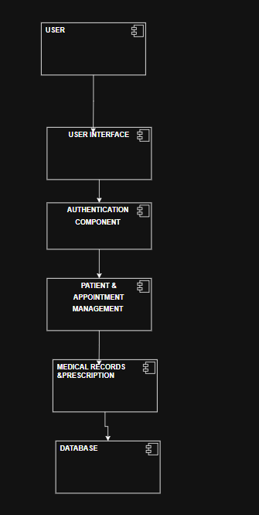

Empirical Estimation
Models:

      - COCOMO MODEL

Boehm’s Project Categories

According to Barry Boehm, software projects are classified into three categories based on complexity, team size, and experience:
- Organic Mode
This type of project is relatively simple and small in size. The team required is small, and the members usually have good experience and familiarity with the application domain. The requirements are well understood, and the project does not involve strict constraints.
- Semi-Detached Mode
In this category, the project lies between organic and embedded types. The team size is moderate, and the team members have mixed levels of experience. The project complexity is also medium, and requirements may not be fully clear at the beginning.
- Embedded Mode
These projects are highly complex and involve strict constraints such as hardware, software, and operational requirements. They require a large team with high expertise and experience. Examples include real-time systems and critical applications.

COCOMO Model (Constructive Cost Model)
The COCOMO (Constructive Cost Model) is a regression-based model proposed by Barry Boehm. It is used to estimate the cost, effort, and time required for software development projects based on the size of the software.

Types of COCOMO Models

- Basic COCOMO Model
This model provides a rough estimate of effort and cost based only on the size of the software (measured in KLOC – Thousands of Lines of Code). It is simple and easy to use but less accurate.
- Intermediate COCOMO Model
This model improves estimation accuracy by considering additional factors called cost drivers (such as product reliability, team capability, and hardware constraints).
- Detailed COCOMO Model
This is the most advanced version. It considers all phases of the software development life cycle and applies cost drivers to each phase, providing the most accurate estimation.

- Basic COCOMO Model

Project Mode | Constant A | Constant B | Constant C | Constant D
Organic | 2.4 | 1.05 | 2.5 | 0.38
Semi-Detached | 3.0 | 1.12 | 2.5 | 0.35
Embedded | 3.6 | 1.20 | 2.5 | 0.32

A. Effort Estimation (E) Effort is the amount of labour (staff) required to complete the task, measured in person-months.
Formula: E = A × (KLOC)^B
Calculation: 2.4 × (18)^1.05
Result: 49.91 Person-Months
B. Schedule Estimation (T)
Time refers to the amount of time required for completion of the job.
Formula: T = C × (Effort)^D
Calculation: 2.5 × (49.91)^0.38
Result: 11.04 Months
C. Staffing Estimation (P)
This estimates the average number of persons required to complete the project within the scheduled time.
Formula: Persons = Effort / Time
Calculation: 49.91 / 11.04
Result: ≈ 4.52 (≈ 5 Persons)

- Intermediate COCOMO Model

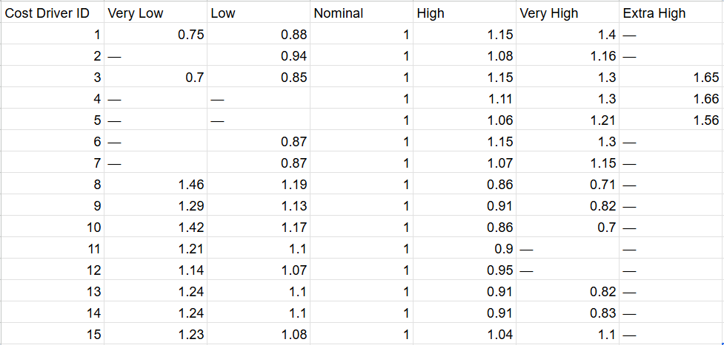

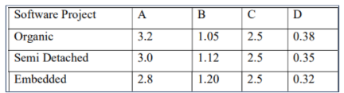

A. Effort Adjustment Factor (EAF)
The EAF is the product of the 15 cost drivers selected from the ratings table.
EAF = 0.66
B. Effort Estimation (E)
Effort is measured in person-months and accounts for the specific project environmental factors via the EAF.
Formula: E = (A × (KLOC)^B) × EAF
Calculation: E = (3.2 × (18)^1.05) × 0.66
Step 1: 3.2 × 20.796 × 0.66
Step 2: 66.55 × 0.66
Result: 43.92 Person-Months
C. Development Time (T)
This estimates the total duration of the project in months.
Formula: T = C × (Effort)^D
Calculation: T = 2.5 × (43.92)^0.38
Step 1: 2.5 × 4.208
Result: 10.52 Months
D. Staffing Requirement (P)
This determines the average number of personnel required for the project duration.
Formula: Persons = Effort / Time
Calculation: 43.92 / 10.52
Result: 4.17 (approx. 4 to 5 People)

